Group #1



***Computer Service Support System (24)***

Phase 1

|  |  |  |
| --- | --- | --- |
| **ID** | **Student Name** | **E-mail** |
| **196280** | Ashraf Adel | ashraf196280@bue.edu.eg |
| **205798** | Eyad Mostafa | eyad205798@bue.edu.eg |
| **197657** | Mohammad Gharieb El Emary | mohammad197657@bue.edu.eg |
| **201573** | Mahmoud Osama Ahmed Hassan | mahmoud20157@bue.edu.eg |
| **179280** | Alaa Mohamed Abdelbaseet Mohamed Ouda | alaa179280@bue.edu.eg |

Table of Contents

1. Requirements Engineering **2**

Introduction 2

System analysis 3

Scope 3

Functional requirements 5

Non-Functional requirements 5

2. Context diagram **6**

3. Use Case Diagram **7**

4. Use Case Scenarios **8**

Scenario 1 8

Scenario 2 9

Scenario 3 10

Scenario 4 11

# 1. Requirements Engineering

## Introduction

This is a help desk for servicing computer parts (CD-ROM, Hard-drive, Floppy, etc.). This system will provide a way for customers to request the repair of computer parts and allow them to view the status of all items being serviced. There are 3 types of users that can log in to the system:

1. regular customer, who can:
   1. View all computer parts that are available for servicing.
   2. Create/Cancel order
   3. Track orders
2. technicians, who can:
   1. Update the status of a certain computer part (received, In-repair, Fixed/Not fixed).
   2. View queue for orders to work on
3. system Administrator, who can:
   1. Add, modify or remove technician and customer accounts.
4. Credit system:
5. Check customer balance to confirm availability of order
6. Send confirmation to the system that the customer can indeed pay.

### System analysis

An order’s life cycle consists of three parts, and will be processed in the following steps: Firstly, the customer will check the availability of the needed items to be repaired. If the items are available, the customer will place the order. Secondly, while placing the order the customer can choose the payment method; if it is using credit, the credit system will check the entered account if it has the sufficient balance to cover the repair items or not, and then send a confirmation or a non-confirmation message back to the customer. Finally, the customer can track the current status of their items online without visiting our branches, but when the current status changes to successfully done, the customer must visit the branch to pick up the item. Note that the technician is responsible for updating the status of the orders that the customer can track.

Regarding the technician: they can view all orders that they are assigned to, in order to recall which orders they should still be working on, and which orders are finished. Note that the system assigns orders to technicians based on how many orders they currently are working on; if a technician has many unfinished orders, the system will assign the order to another technician. Finally, they can update the status of the current orders that they are working on, as mentioned, before where this status could be:

1. Not received: the order is placed, but the customer still didn’t deliver the item to the branch.
2. Received: the items are currently within the technician’s possession but they haven’t started working on it yet.
3. In-repair: the items are currently being repaired.
4. Fixed: the technician fixed the items.
5. Not fixed: the technician wasn’t able to fix all the items.

Regarding the admin: they can modify a customer account if the customer requested for a change of account’s info. They can also modify a technician’s account if they see they want to hire a technician, fire them, or simplify access to their data and modify them. Finally, they can view a report listing all the orders that were created in a specific time range specified by the admin.

### Scope

1. The customer must be aware of the location of our branches because the system will not display the list of available branches.
2. The system isn’t responsible for the actual payment of the customer;
   1. if he creates the order stating that the payment method is cash, it is the responsibility of the branch to receive payment from the customer when the item is fixed and the customer visits the branch to receive it.
   2. If the payment method is using credit, the system is only responsible for checking the credit’s balance to accept the initial order request. It is not responsible for withdrawing the money from the customer’s credit once he visits the branch to receive the fixed item.
3. The system won’t be covering the internal aspects of our branches; how and when technicians are getting salary raises, who manages each branch and the chain of command in general, etc.

## 

## Functional requirements

|  |  |
| --- | --- |
| Function | Description |
| Search computer parts | The system must provide the customers with the ability to search for all computer parts available for servicing. |
| Create/Cancel order | The system shall provide the customers with the ability to create or cancel an order. |
| Track orders | The system must provide customers with the ability to view current status of their orders. |
| Update order status | The system shall provide technicians with the ability to update the status of each computer part per order that they are working on, and then send these updates to the customer. |
| View order queue | The system must allow technicians to view their queue for orders they should be working on. |
| Modify account | The system shall allow the system administrator to modify, add or remove technician or customer accounts |
| View report | The system shall allow the administrator to view a list of the orders made by customers in a specific time interval. |
| Check credit | The system must allow the credit system to check the customer balance; their balance should be enough to pay for the repair service in their order. |
| Send confirmation message | The system shall allow the customer to receive a confirmation message from the credit system that specifies whether or not the customer can pay using his credit card. |

## Non-Functional requirements

1. Availability: The computer service system should be available 24/7 even when requested on national holidays because even though the branches will be closed that day, the customer should still be allowed to create an order.
2. Size: Since the shop’s branches are currently based in Egypt, the records won’t exceed 1 million records
3. Portability: Since most Egyptians use windows, the system is expected to work on windows.
4. Reliability: Since the system is not life-critical to the user, the system could go down for a maximum of 1 time per week.
5. Ease of use: the customers that use the system should understand how to place, remove and check their orders in 2 minute or less. Meanwhile, the staff working on the system will train on the system for 3 hours, and then each of them is expected to not exceed 2 mistakes per hour when using the system.
6. Speed: the system should inform the customer about his order status in a maximum of 5 minutes.

# 2. Context diagram

## 

# 3. Use Case Diagram

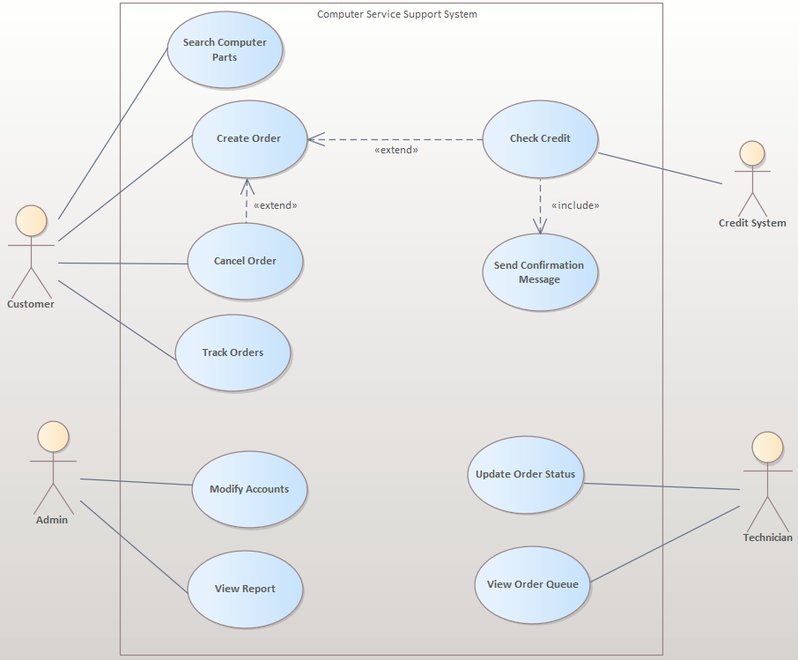

# 

# 4. Use Case Scenarios

## Scenario 1

|  |  |
| --- | --- |
| ID | UC_01 |
| Title | Search computer parts |
| Description | The customer finds a problem with their computer part, so they search our system to know if our branches could repair said part. |
| Priority | Medium |
| Primary Actor | Customer |
| Secondary Actor | None |
| Pre-Conditions | The customer must be logged in. |
| Post-Conditions | The system informs the customer if our branches could repair the part(s) searched for. |
| Main Success Scenario | 1. The customer types the name of the computer part that he wants to search for. 2. The system confirms the availability of the searched part. |
| Extensions | 1a. The customer types a computer part that is not available in our system, the system informs the customer that this item is not available for repair and displays the list of computer parts that could be repaired by our branches. |

## 

## 

## 

## Scenario 2

|  |  |
| --- | --- |
| ID | UC_02 |
| Title | Create Order |
| Description | The customer has chosen his computer part that he wants to fix and wishes to create an order. |
| Priority | High |
| Primary Actor | Customer |
| Secondary Actor | Credit System |
| Pre-Conditions | The customer must be logged in, and be aware of the parts available in our system. |
| Post-Conditions | The system informs the user if the order has been created or not, along with the confirmation message that his balance is sufficient if the customer has chosen a credit card as his/her payment method. |
| Main Success Scenario | 1. The customer types in the computer part that he/she wants to repair. 2. The customer chooses the payment method (Cash or Credit) and submits the order into our system. 3. The system checks if there are available technicians and if so, assigns the order to them. |
| Extensions | 1a. The customer types a computer part that isn’t available in our system, the system notifies the customer and cancels the order.  2a. The customer chooses the credit card as the payment method and there’s insufficient funds in the submitted credit card, the system will notify the customer and discontinue the process.  3a. There are no technicians available, the system notifies the customer that the order could be placed, but he/she won’t visit the branch until a technician becomes available to repair the computer part. |

## Scenario 3

|  |  |
| --- | --- |
| ID | UC_03 |
| Title | View Report |
| Description | The system administrator views the report of orders in a specific time interval which is automatically generated by the system through sorting. |
| Priority | Medium |
| Primary Actor | System Administrator |
| Secondary Actor | None |
| Pre-Conditions | The admin must be logged in. |
| Post-Conditions | The system shows the admin the requested report. |
| Main Success Scenario | 1. The admin types a starting and ending time interval. 2. The system generates a report of orders within the selected time interval and displays it to the administrator. |
| Extensions | 1a. The admin enters the time intervals in a format that cannot be parsed, the system prompts the admin to enter the time interval in a specific format (DD-MMM-YYYY HH:MM:SS, etc.).  2a. The admin types an ending time interval that is less than the starting time interval, the system prompts the admin to change the input.  2b. No orders are created in the time interval selected by the administrator, the system will notify the admin that there are no orders which have been created in this time interval. |

## 

## Scenario 4

|  |  |
| --- | --- |
| ID | UC_04 |
| Title | Cancel Order |
| Description | The customer has decided for any reason that he doesn’t want his/her item repaired and wants to cancel the order, or wrong input was typed while creating the order, or the credit system finds that there are insufficient funds for the transaction to be completed. |
| Priority | High |
| Primary Actor | Customer |
| Secondary Actor | Credit System |
| Pre-Conditions | The customer should be logged in, the order must still be in processing (computer part is not delivered to the branch). |
| Post-Conditions | The customer is notified of the order’s cancellation and the order status is updated to “cancelled”. |
| Main Success Scenario | 1. The system displays a list of the customer’s orders that are not yet received by one of our branches. 2. The customer selects one of the displayed orders. 3. The system updates that order to “cancelled”. |
| Extensions | 1a. If the order has passed the processing phase (a technician has the computer part), the system won’t display this order from the list of orders that the customer can cancel.  2a. The customer selects an invalid order, the system notifies the customer and prompts him/her to re-select the order or terminate the cancellation process. |